Exp.No:25
25. Perform Sharpening of Image using Gradient masking.

Aim:
To sharpen an image using Gradient Masking with the Sobel operator in OpenCV.
Procedure:
- Read the input image Rabbit.jpg.
- Convert the image to grayscale.
- Calculate the gradient in the X direction using Sobel.
- Calculate the gradient in the Y direction using Sobel.
- Combine both gradients.
- Add the gradient mask to the original image.
- Resize the images for medium-sized display.
- Display and save the sharpened image.
Program:
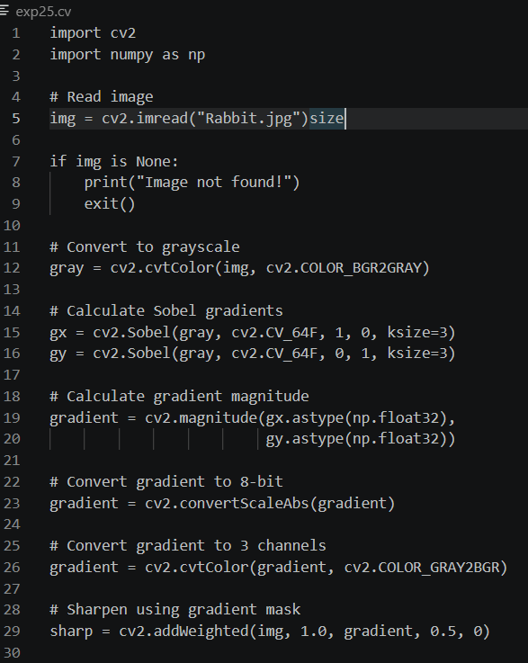

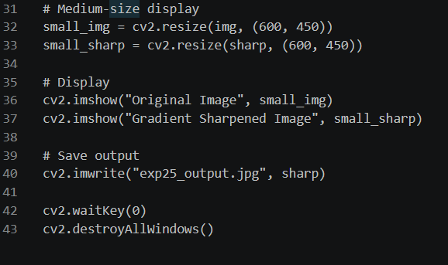
Input:
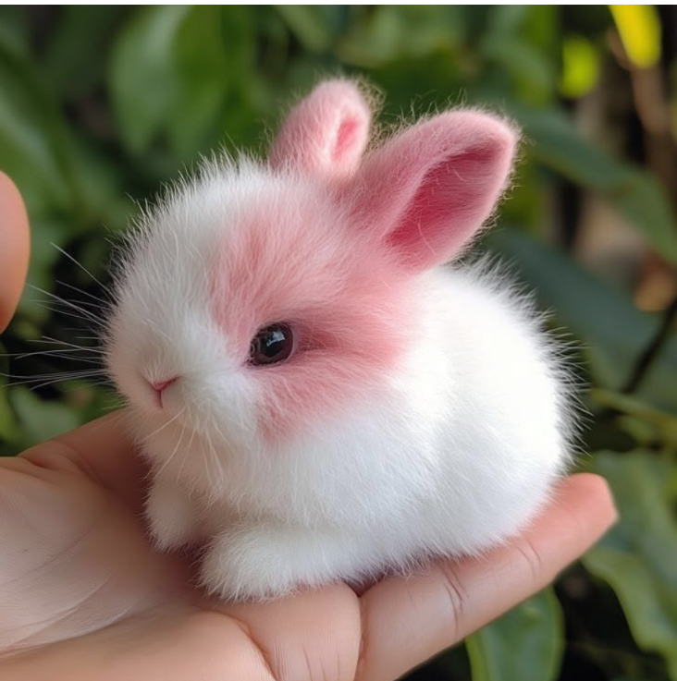

Output:
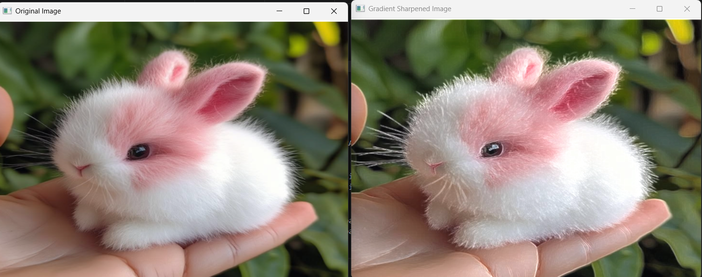

Result:
The image was successfully sharpened using Gradient Masking, and the sharpened image was displayed and saved successfully.

